

CHILDREN AND FAMILY COURT ADVISORY AND SUPPORT SERVICE

Paper for the Board meeting on 01 December 2006

PERFORMANCE REPORT

1 AIM AND PURPOSE

1.1 To provide the Board with an update overview of the operational service position as at 30 September 2006 – Quarter 2.

2 ACTION FOR THE BOARD

2.1 This report is for information and discussion only.

3 RECOMMENDATION

3.1 For the Board to note the report and key issues.

4 KEY STRATEGIC ISSUES FOR THE BOARD TO CONSIDER

Key Performance Indicators | Target / Norm | Performance | Year to Date
1 – S31 allocations within 2 days | 70% | ☹ | 55.2%
2 – Total allocations within 28 days | 98% | 😐 | 93.7%
3 – Public unallocated | 3% | ☺ | 2.6%
4 – DR’s with full/partial agreement | 55% to 65% |  | 59.8%
5 – DR’s referred for S7 | 35% to 45% |  | 20.3%
6 – Service user diversity | 65% | ☹ | 47%
7 – Appraisals completed in 12 mo. | 100% | ☹ | 45.9%
8 – Sickness Absence | 4% | 😐 | 4.1%
A – Private unallocated <10 weeks | 4% | ☺ | 3.8%

Sherry Malik Allison Calvert

Corporate Director, Strategy & Performance Corporate MIS Manager

KPI 1 – 70% of allocations during the month for Section 31 cases (care and supervision) should be within 2 working days from receipt of request (receipt day counted as nought).
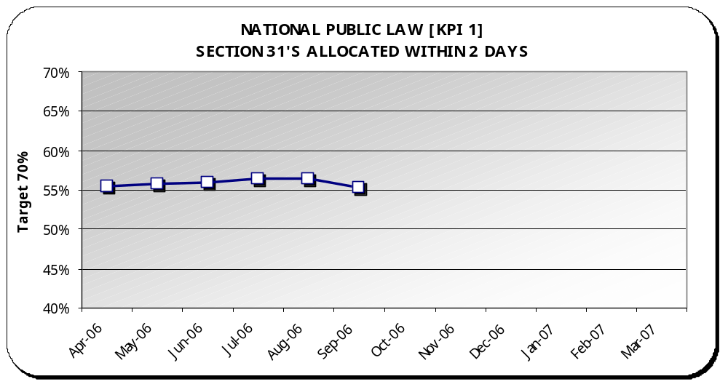 | Target | Performance | Year to Date
 | 70% | ☹ | 55.2%

Analysis
Graph - Year to date performance has fallen slightly from 56.2% to 55.2% as at the end of September.

Best Performance – East Midlands (96%)

Regional Hotspots - Greater London (19%), North East (37%), West Midlands (43.3%), South East (44.3%), Eastern (51.9%) and Yorks and Humberside (58.7%).

Performance Changes –
-  Yorks and Humberside moved from amber (61.6%) to red (58.7%).

Comparison – This year’s Q2 was 54.7% compared to last year’s Q2 of 47.1%.

NB: This graph shows the performance each month as a year to date percentage. Year to date percentages are used to build a picture of performance as the year progresses. This is also the most accurate picture given that the Case Management System allows for timely reporting of amendments.

KPI 2 – At least 98% of all public law allocations each month for all case types should be within 28 working days from receipt of request.
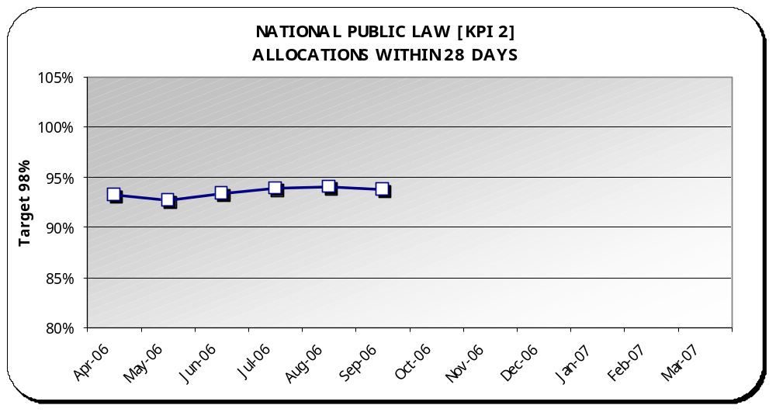 | Target | Performance | Year to Date
 | 98% | 😐 | 93.7%

Analysis
Graph - Year to date performance has fallen slightly from 94% to 93.7% as at the end of September.

NB - August amendments - from 93.6% to 94%

Best Performance – East Midlands (100%)

Regional Hotspots - North East (83.4%), Greater London (87.8%) and West Midlands (88.2%).

Performance Changes –
-  Eastern moved from red (89.3%) to amber (90.2%)
-  Yorks & Humberside moved from green (98.5%) to amber (97.8%).

Comparison – This year’s Q2 was 94.1% compared to last year’s Q2 of 89.5%.

NB: This graph shows the performance each month as a year to date percentage. Year to date percentages are used to build a picture of performance as the year progresses. This is also the most accurate picture given that the Case Management System allows for timely reporting of amendments.

KPI 3 – No more than 3% of the public law workload should remain unallocated at month end.
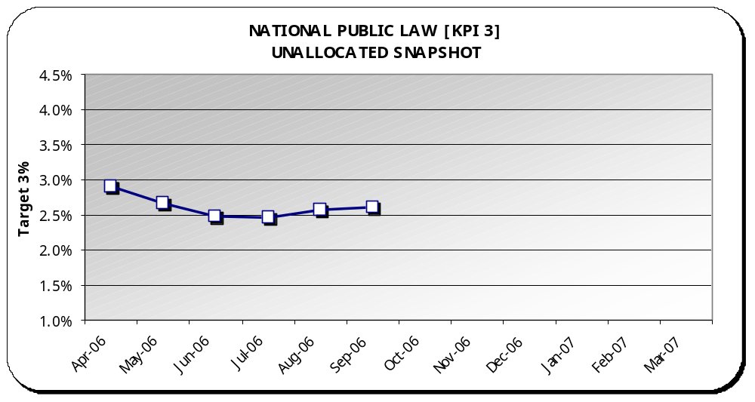 | Target | Performance | Year to Date
 | 3% | ☺ | 2.6%

Analysis
Graph - Year to date performance has stayed the same at 2.6% as at the end of September.

Best Performance – East Midlands (0.3%)

Regional Hotspots - North East (7.7%) and West Midlands (4.2%).

Comparison – This year’s Q2 was 2.8% compared to last year’s Q2 of 2.9%

Backlog - A low level of unallocated public law cases is being sustained against the target. September’s backlog was 339 cases.

NB: This graph shows the performance each month as a year to date percentage. Year to date percentages are used to build a picture of performance as the year progresses. This is also the most accurate picture given that the Case Management System allows for timely reporting of amendments.

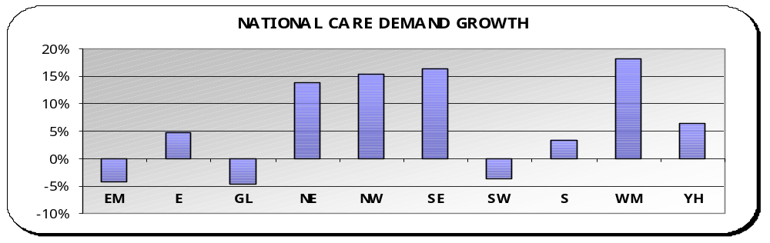 | Public Law demand - In comparing this year to date to the same period last year, Public Law care requests are up 6.2%. Seven regions are showing increases in demand to date compared to the same period last year.  Overall Public Law requests, when including all types of proceedings, were up 2.7% comparing the same period.
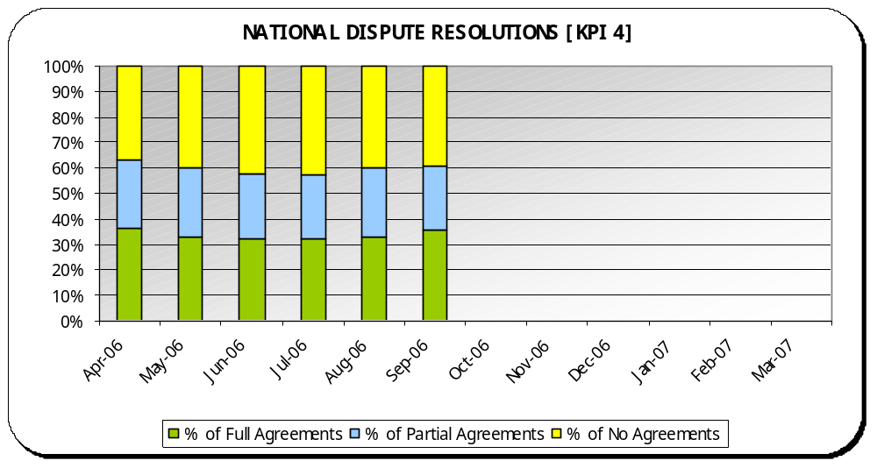
KPI 4 – Percentage of dispute resolutions (including extended dispute resolutions) resulting in full or partial agreement.
 | Norm | Performance | Year to Date
 | 55% to 65% |  | 59.8%

Analysis
Graph - Year to date performance has improved slightly from 59.7% to 59.8% as at the end of September.

Max – Eastern (73.5%)

Min – South East (54.5%)

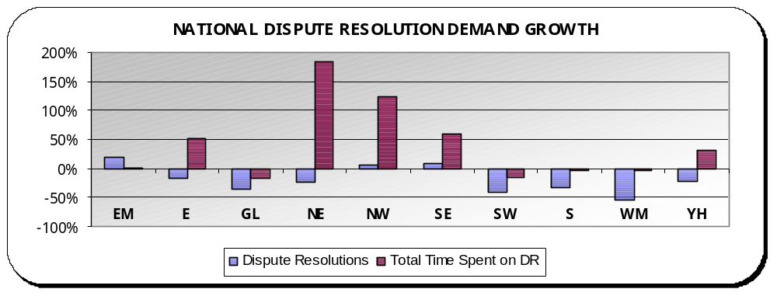 | Dispute Resolutions: In comparing this year to date to the same period last year, Dispute Resolutions are down 23.1%. Three regions are showing increases.  Hours spent on Dispute Resolutions are up 6,244 hours compared to the same period last year. This equates to a 29.9% increase with six regions showing increases.
KPI 5 – Percentage of Section 8’s referred for dispute resolution that are then, referred for a Section 7.
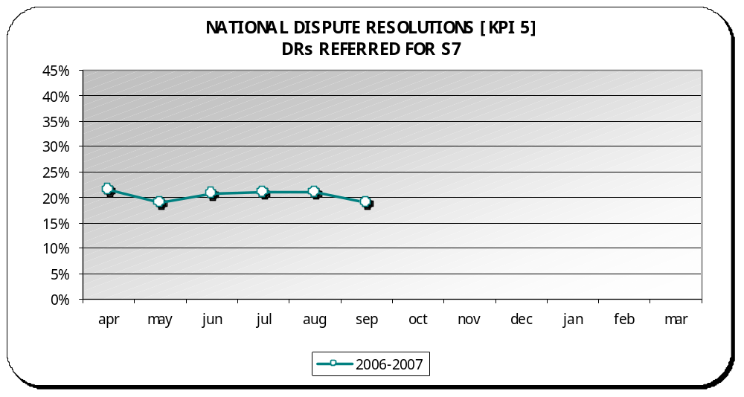 | Norm | Performance | Year to Date
 | 35% to 45% |  | 20.3%

Analysis
Graph - Year to date performance has improved slightly from 21.6% to 20.3% as at the end of September.

Max – South East (29.5%)

Min – Eastern (12.8%)

NB: This graph shows the performance each month as a year to date percentage. Year to date percentages are used to build a picture of performance as the year progresses. This is also the most accurate picture given that the Case Management System allows for timely reporting of amendments.

NB: Rollout of CMS teams this year – due to the changing work of private law and the subsequent changes required for CMS, KPI 5 for CMS teams is not currently measured and will be unavailable until a new report is completed by our service provider. Once completed, figures will be updated.

KPI 6 – 100% diversity monitoring forms returned for all service users by year-end.
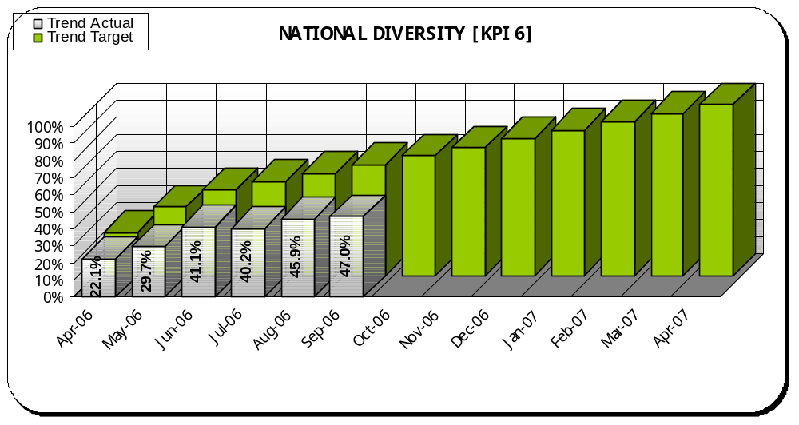 | Interim Target | Performance | Year to Date
 | 65% | ☹ | 47%

Analysis
Graph - Year to date performance has improved slightly from 45.9% to 47% as at the end of September.

Best Performance – North East (68.7%)

Regional Hotspots – Greater London (32.7%), North West (33.3%), West Midlands (34.9%), Southern (45%), South West (47.3%), South East (48%) and East Midlands (48.3%)

Performance Changes –
-  South West moved from amber (50%) to red (47.3%).

NB: This graph shows the performance each month as a year to date percentage against a progressive monthly interim target. Year to date percentages are used to build a picture of performance as the year progresses. This is also the most accurate picture given that the Case Management System allows for timely reporting of amendments.

Diversity: Since the introduction of a new KPI in April of 100% forms returned for all parties and children in new cases by the end of 2006-2007, all regions have been concentrating on improving their returns, and many have action plans in place. While there is a continuing upward trend from August (45.9%) to September (47%), nationally we are still not meeting the interim monthly target. 15.9% of teams are meeting the stretch interim target of 65% for September and another 14.5% of teams were on-target with more than 55% returned.

KPI 7 – 100% appraisals completed for all staff within a 12-month rolling period.
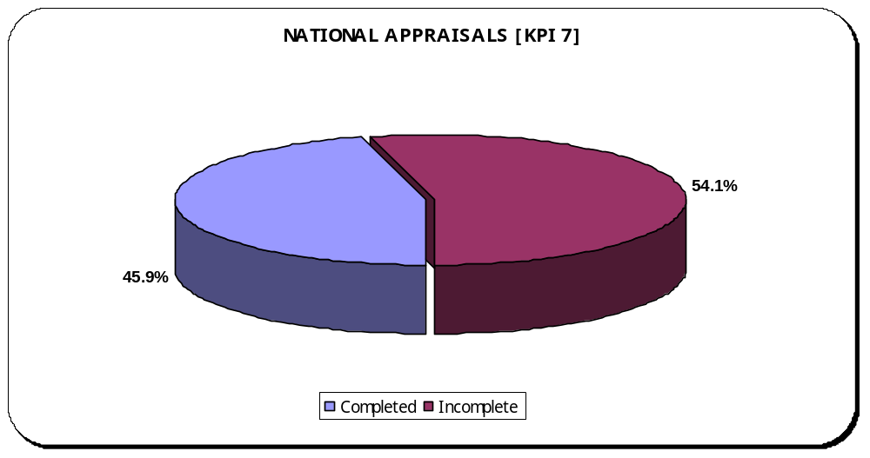 | Target | Performance | Year to Date
 | 100% | ☹ | 45.9%

Analysis
Graph - Year to date performance has fallen from 48.2% to 45.9% as at the end of September.

Best Performance – North East (97.4%) and Yorks & Humberside (90.7%)

Regional Hotspots – West Midlands (18.8%), South East (20.8%), Greater London (22%), National Office (28.8%), South West (31.9%), Eastern (35.6%), East Midlands (42.3%), Southern (43.4%) and North West (73%).

Appraisals: The Quarter 2 regional performance monitoring is currently underway. This KPI and surrounding issues will be scrutinized where performance is low.

KPI 8 – Sickness absence rate of no more than 4% should be maintained.
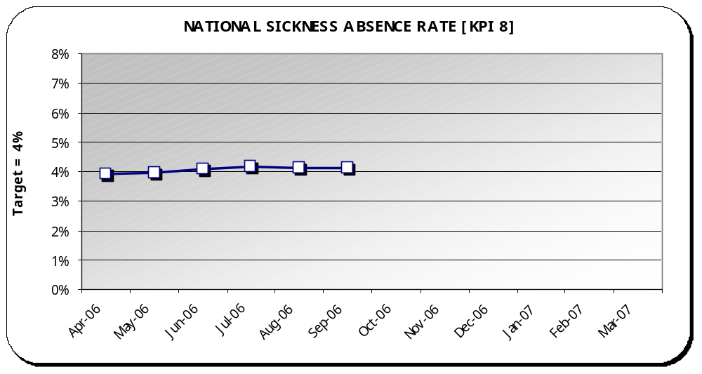 | Target | Performance | Year to Date
 | 4% | 😐 | 4.1%

Analysis
Graph –Year to date performance has stayed the same at 4.1% as at the end of September.

NB – Statistical revisions in-line with year to date reporting.

Best Performance – South West (1.4%)

Regional Hotspots – Southern (5.9%), North West (5.4%), East Midlands (5%) and West Midlands (5%).

Workforce: Nationally, sickness absence at 4.1% is on-target to meet 4%. Much of the sickness in the regional hotspots is down to long term sickness of a small number of staff and plans are in hand to address this through occupational health. Increasing demand can also place pressure on a regions capacity. There is still a missing capacity of 37.7 WTE (whole time equivalent) for FCA’s and 3.2 WTE for Service Managers across all regions.

Private Law Summary
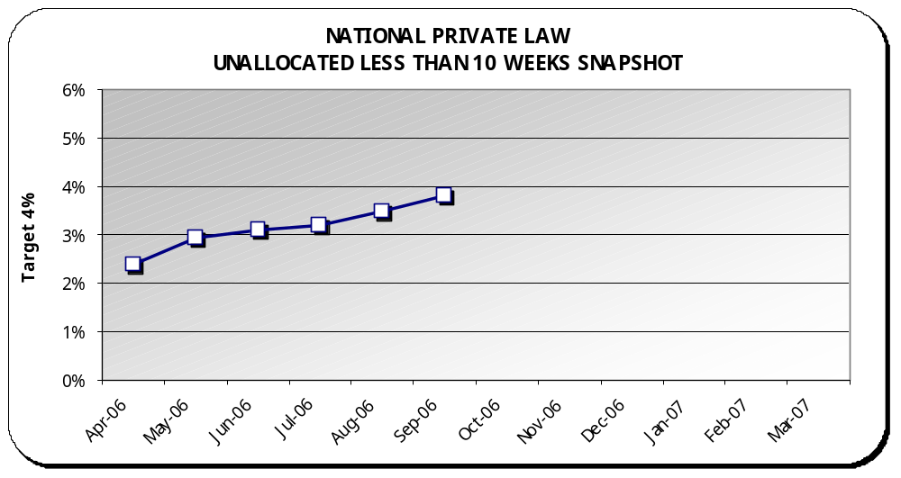 | Target | Performance | Year to Date
 | 4% | ☺ | 3.8%

Analysis
Graph - Year to date performance has increased from 3.5% to 3.8% as at the end of September.

Best Performance – East Midlands (0.1%)

Regional Hotspots – South East (9.5%) and West Midlands (6%).

Performance Changes –
-  North East moved from green (4%) to amber (4.4%)
-  North West moved from green (4%) to amber (4.3%)
-  South West moved from green (3.6%) to amber (4.1%)
-  West Midlands moved from amber (4.7%) to red (6%)

Comparison – This year’s Q2 was 4.5% compared to last year’s Q2 of 3.5%

Backlog - A low level of unallocated public law cases less than 10 weeks is being sustained. September’s backlog of cases less than 10 weeks was 445 cases. Total unallocated backlog was 1324 cases.

NB: The graph above shows the performance each month as a year to date percentage. Year to date percentages are used to build a picture of performance as the year progresses. This is also the most accurate picture given that the Case Management System allows for up to the minute reporting of changes.

Private Law Summary continued
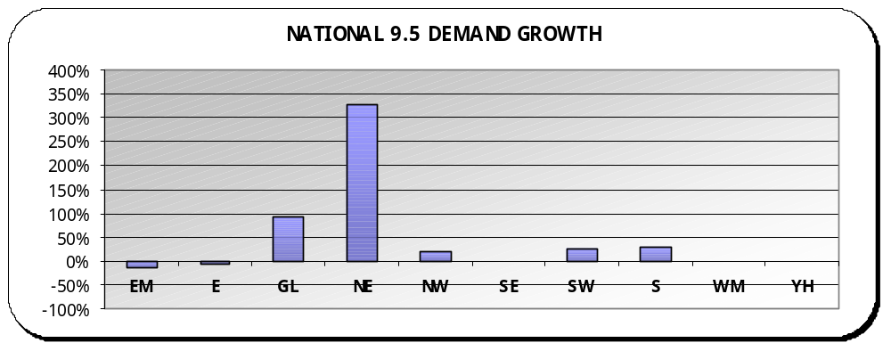 | Private Law demand - Comparing this year to date to last year, Rule 9.5 cases are up 18.5% (94 cases) compared to last year, with five regions showing an increase.  NB - North East’s increase relates to 23 cases and Greater London’s increase relates to 35 cases.  Overall, Private Law report requests were down nationally 12.9%. All regions are reflecting this downward trend in total private law reports.  Family Assistance Orders - In comparing this year to date to the previous year, FAO’s are down 17.4% (60 orders). Yorks & Humberside is the only region with an increase (12 orders).
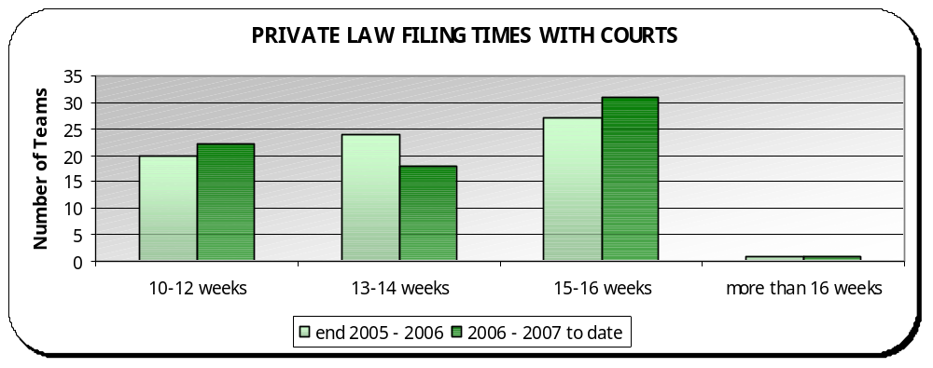 | Private Law Court Filing Times - 30.6% ☺ of teams meet the standard filing time of 10–12 weeks, 25% 😐 of teams are on target to meet the standard with 13–14 weeks, 43.1% of teams have filing times of 15–16 weeks ☹ and 1.4% of teams are filing more than 16 weeks ☹ (1 team). This is Slough, which is filing in 24 weeks.  Performance Changes – (in weeks)  -  East Kent (from 17 to 16)  -  Guildford (from 14-16 to 12-14)  -  Gloucester (from 13 to 12)  -  Wiltshire (from 13 to 12)  -  Reading (from 16 to 14  -  Batley (from 16 to 14)  -  West Kent (from 13-14 to 16)  -  East Sussex (from 10-12 to 13-14).

Finance Summary
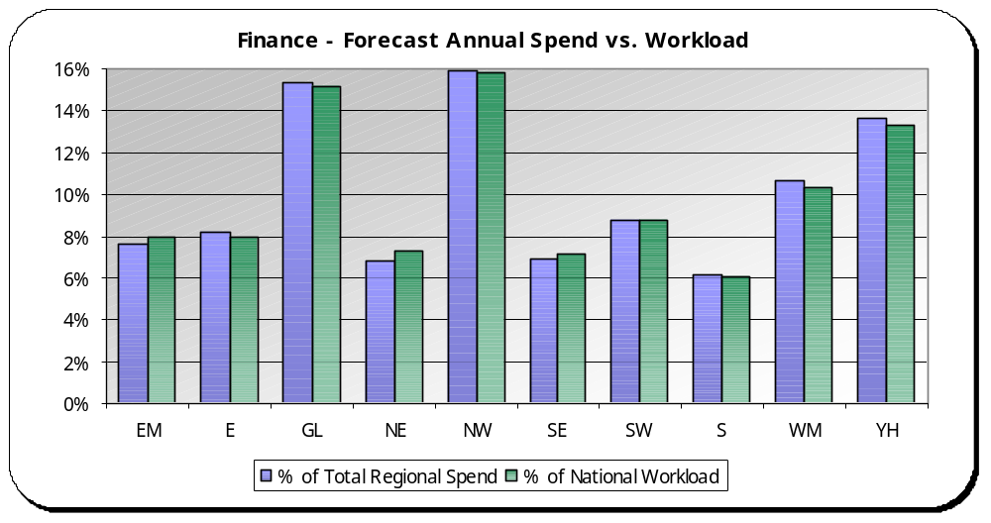 | Analysis  Overall, there is a strong correlation between resource use and activity with no real significant outliers.  Most Efficient – North East is showing as the most efficient region, undertaking 7.3% of the work and using 6.8% of the resources.  Least Efficient –West Midlands and Yorks & Humberside are showing as the least efficient regions, using a greater percentage of resources compared to their share of workload activity.

NB: Forecasts are produced quarterly and workload is calculated monthly based on a rolling 12-month period.

Finance: This graph compares each region’s use of resources compared to their workload.

The percentage of spend is calculated by taking the regions quarter 2 forecast spend as a percentage of total regional forecast spend at quarter 2. The percentage of workload is calculated by taking the regions total rolling 12-month workload (as at September 2006) as a percentage of total national workload (as at September 2006).

It is expected that these two percentages should equal. If the percentage of spend is lower than the percentage of workload then this indicates efficiency.

